REGRESSION ANALYSIS-ASSIGNMENT

DUE March 27

Your Assignment:

- Using Excel or another program with plotting functions, construct two XY(scatter) graphs, one for 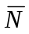, one for ln(). There will be two curves/lines on each graph, one for each group. Before printing and saving the graphs, remove the gray fill in the plot area.

Your data table will have five rows and four columns for each group.
For instance, [the background has been subtracted.]
x |  | S | ln()
0.1 | 690 | 35 | 6.54
0.2 | 488 | 45 | 6.19
0.3 | 340 | 34 | 5.83
0.4 | 230 | 25 | 5.44
0.5 | 169 | 20 | 5.13

- Graph the average counts per minute, , vs. x, the thickness of material. Add error bars to the data points. Here’s how in Excel:

Select the data series on the graph
Select the format menu
Select format selected data series
Select the y error bars tab, then select custom
Select the standard deviation column for both the + & - error bars

- Graph the ln() vs. x. Perform the linear regression according to the instructions on pages 14-18 in the ring binder.

The slope is the “x variable 1”. The p-value is the “significance F.”

Finally, add a trend line to the graph. Here’s how to do that in Excel:

Select the chart menu.
Select add trend line
Select the type tab—choose linear
Select the options tab—check display equation on chart & check display R² value on chart.

- SAVE the Excel file before or after printing out the charts on separate pages. Print also the linear regression out put. You’ll need the file for the Presentation, as well as the Written Report.
Continued on the back of this page. . .
- Fill in the regression tables (on the following page) and hand in one copy of the graphs and statistical output, that is the Excel file if you used Excel, and the regression tables..

- The absorption coefficient for each material and radiation combination is the negative of the slope. In the example graphs below, the absorption coefficients for gamma radiation are:
material | absorption coefficient
Aluminum | 3.57 cm⁻¹
Lead | 7.30 cm⁻¹

Here are some example graphs:

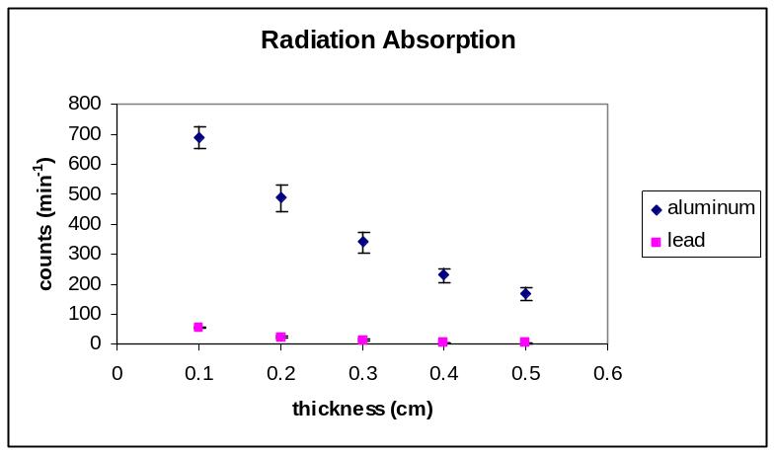

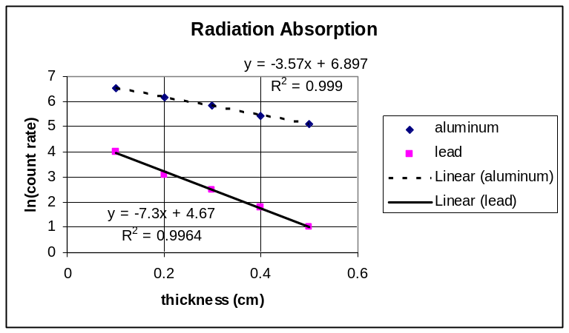

HYPOTHESIS TESTING USING STATISTICAL ANALYSIS

Regression Analysis #1 (Group A, Variable 1 vs. Variable 2)

Regression Equation:

R-squared value:

F statistic:

P-value:

Conclusion: Is there is statistically significant linear relationship
between the two variables YES or NO (circle one)

Regression Analysis #2 (Group B, Variable 1 vs. Variable 2)

Regression Equation:

R-squared value:

F statistic:

P-value:

Conclusion: Is there is statistically significant linear relationship
between the two variables YES or NO (circle one)

